

Dr. David, Baker inc.

2021-09-12

Dr. Baker

37452 Claudia Radial, East James, WY 78344

Phone: 914370394

Fax: 3315787234

**Re:** Lacey, Blair

**PHN:** 1660034260

**Birthdate:** 11-Dec-1950

**Address:** 216 Mary Spurs Apt. 457, Lake Jonathanfort, VI 33351

**Patient number:** 985168386

To Whom It May Concern:

This is a medical letter to state the above patient is pregnant with expected delivery date of 09-Aug-2025. Hoping this information is satisfactory for your requirements.

Thank you.

Sincerely,

Dr. David, Baker

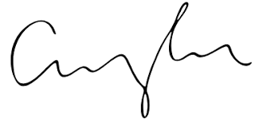

FRCS© NCMP

Clinical Assistant Professor, UBC

Department of Obstetrics and Gynecology SMH